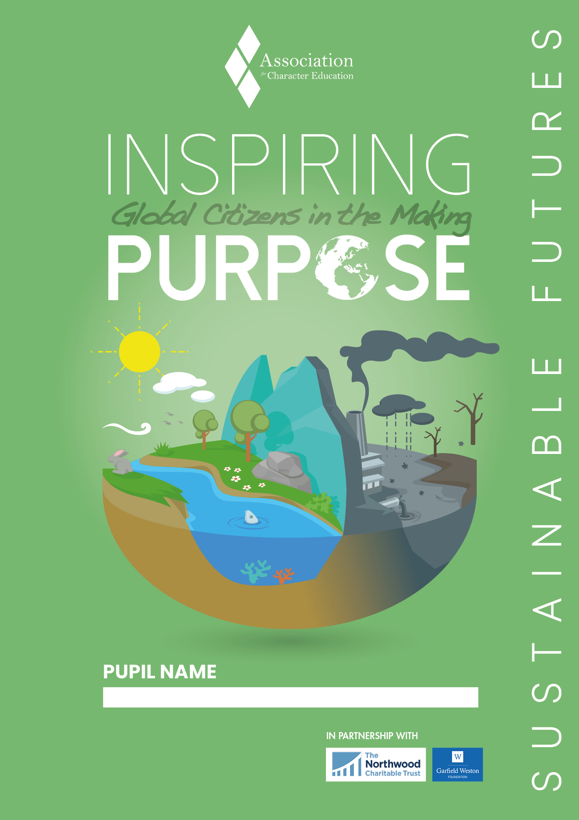

INSTRUCTIONS: SUSTAINABLE FUTURES
Sense of Purpose - The motivation that drives you towards a satisfying future.
‘Inspiring Purpose’ is a personal development programme that aims to help you discover who you are and who you could become. You will learn about character, virtues and strengths and use these to define your purpose, your goals and your vision for a sustainable future.
Activity 1 Virtues and Values
The first four boxes have an activity area. Each section lists some qualities linked with a particular value associated with the lessons we can learn from the challenges of change. Rank these qualities in the order that best describe you, with No. 1 being your strongest quality. Now write a short statement in the left-hand box to explain the quality that best describes you. In the right-hand box explain your choice of quality you most need to work on.
TIP: Use our website to explore the meaning of virtues and values and don’t forget to ask for help if you are still not sure what to do.
Activity 2 Endangered Species or Significant Environmental Issue
EITHER choose an endangered species, explain why it is under threat, why it is important and how you would recommend conserving it, OR choose an environmental issue, explain its significance for you and how you would recommend tackling it.
Activity 3 Who Inspires You and Why?
We can be inspired by the actions and achievements of others in ways that can help us make a success of our own lives. Choose an inspiring person, story or project related to sustainable futures. Perhaps there is a story you could tell from you own experience and what you have learned. What virtues and values does the person, story or project demonstrate? How are the principles of sustainability applied? Why do you find the people involved inspiring? What is it about them that you admire? Do they have ideals, values, or characteristics that you would like to live up to?
TIP: Remember it is not just about writing. You could include drawings, pictures or embed video content. You will find resources on the website to help you choose and research your inspirational figure.
Activity 4 Inspiring Quotes
We can learn so much from the wisdom and experience of others expressed in short quotations and maxims. Do you have a memorable quotation from your inspirational figure or from some other source?
Activity 5 Photo or Video
Insert a photo or embed a video into the space provided and explain your choice, perhaps relating it to your inspiration. You can either choose a photo/video showing something that is wrong and needs changing or a photo/video demonstrating something you like or would like to see done.
Activity 6 My Aspirations
By completing this programme you have learned some new things about yourself, about others and about the world. You can now work out what kind of person you want to be and become. Think about how you feel about a sustainable future, what you are grateful for and what you think needs to change. There is space for you to write about what you think should be the priorities for a sustainable future. Finally, reflect on how this exercise has helped you define your purpose and aspirations and how you can make a personal contribution. By developing your own vision, you can make plans and decisions, then act on them to create your own future.
TIP: Think carefully and answer the questions as best you can. Do not rush – reflect first and write from the heart! You can include drawings or photos to get across what you want to say.
This education programme originates from Sir John Templeton’s work on the ‘Laws of Life’ and we are grateful to his Foundations for their support. © Copyright 2007-2020 Character Education Scotland Ltd. All rights reserved. Image: Freepik.com. This cover has been designed using resources from Freepik.com

Your Details

2. Endangered Species or Significant Environmental Issue
Co-operative

Forgiving
Trustworthy

Organised
Hard-working

Determined
Resilient

Self-Disciplined

Thorough

Motivated
Civic Character > Effective Contributors

Moral Character > Responsible Citizens

Performance Character > Confident Individuals

Intellectual Character > Successful Learners

Critical
Open-minded

1. Self-reflection: Your Character
NOTE: Please read the instructions on the back page!

Committed

Responsible

Principled

Generous

Respectful

Enterprising

Selfless

Honest

Kind

Appreciative

Caring

Enthusiastic
Incisive

Curious

Creative

I need to work on being...

I am good at being...

3. Who Inspires You and Why?
NOTE: Before you proceed, please read the instructions on the back page!

4. Inspiring Quotes

5. Photo or Video

[Insert Photo/Video here]

C. How are you personally planning to contribute to a sustainable future, perhaps in your own community?
B. What are your top key ideas and priorities for a sustainable future?
A. What do you want to achieve and contribute in your life?

6. My Aspirations
NOTE: To help you answer these questions; look back at your character attributes, endangered species or significant environmental issue and inspirational figure.

A. What did you learn or achieve by taking part in this project? Please explain and provide a specific example:

Learner Evaluation

Ask a friend to review your poster and write down what they think about your personal qualities and goals:

(OPTIONAL) Ask a parent to read your poster and add their comments here:

B. Please tell us how you think we could improve the project for next year:

They worked pro-actively and enthusiastically to complete all poster elements

After reading, I have learned something special and compelling about the pupil

There is clear identification of their values, qualities and feelings

They have identified the qualities they admire in others

There is a connection between: their values, other poster elements and future ambitions

They have identified what they have learned about themselves

Another person commented upon their values and goals

I believe this process has increased their self-awareness and encouraged them to set
a goal for the future

Teacher Comments:
The aim of the programme is to inspire purpose in young people – what ‘change’ have you experienced in this young person?
Learning Outcome Checklist (SQA PDA Self-Awareness Unit H18X44)
Please indicate the extent to which you agree or disagree with each statement by writing in the appropriate number:
1 = strongly disagree, 2 = disagree, 3 = agree, 4 = strongly agree
Teacher’s Section

Yes

No
Did you help your child complete this work?

Peer Evaluation

