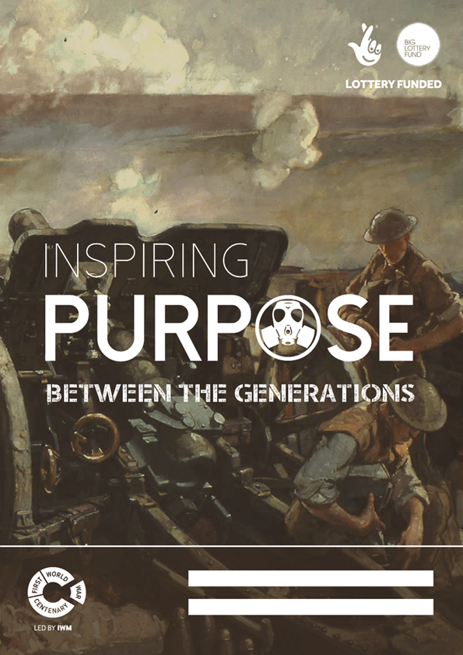

*Inspiring Purpose is a project of Character Education Scotland Ltd registered charity in Scotland No. SC040962*

Names

**We have created this poster template to mark the centenary of the First World War and provide the opportunity to complete a joint project between two people from different generations. This could be a grandparent and grandchild or other family relative or friend. Completing this poster together will help you learn about the values from WW 1 and the heroic stories of those who fought and suffered on the front, often making the ultimate sacrifice. In this joint process, you will work together and learn from each other as well as from history. This exercise will enable you to think about purpose in life and about the values and qualities needed for a fulfilling and happy life.**

How to complete your poster...

**Activity 01-04 Virtues and Values**

The first four boxes have an activity area on the left page of your poster. Each section lists some qualities linked with a particular value associated with the lessons we can learn from World War 1.

*Think about these qualities and rank them together in order of importance by putting 1-7 next to the words. Then the senior person should write a short statement in the left-hand box to explain the quality that best describes them and the junior person should do the same in the right-hand box.*

***TIP: Use the website to explore the meaning of virtues and values and don’t forget to ask for help if you are still not sure what to do.***

**Activity 05 Our Favourite World War 1 Poem**

Many famous poems were written during World War 1 by combatants on all sides. Choose a poem and write a few words about your choice (NB you can fold extra paper into the space if you need to).

**Activity 06 Inspiring Story/Person**

We can be inspired by the actions and achievements of others in ways that can help us make a success of our own lives. Choose an inspiring story involving a particular soldier, nurse, stretcher-bearer, other personnel or those left at home. You might research a relative or individual from your local war memorial. If you have been to a battlefield site yourself, you could tell the story of your experience and what you learned.

*What virtues did they demonstrate and what values did they demonstrate? Why do you find them inspiring? What is it about them that you admire? Did they have ideals, values or characteristics that you would like to live up to?*

***TIP: Remember it is not just about writing. You could include drawings or pictures. You will find resources on the website to help you choose and research your inspirational figure.***

**Activity 07 Inspiring Quotes**

We can learn so much from the wisdom and experience of others expressed in short quotations and maxims.

*Do you have a memorable quotation from your inspirational figure or from some other source?*

**Activity 08 Photo/Painting**

Paste a photo or painting into the space provided and explain your choice, perhaps relating it to your poem, inspiring story or favourite quotations.

**Activity 09 Our Reflections**

By completing this poster, you have learned some new things about yourself, about each other and about the world. Think about the value of human life, what you are grateful for and how valuable your time is – many soldiers were killed when they were 18-19. Like the junior partner, they thought they had their whole lives in front of them. Then reflect about what you have learned from and about each other during this exercise. Finally, reflect on your vision for a more peaceful world and how you can help bring this to life.

*By developing your own vision, you can make plans and decisions, then act on them to create your own future.*

***TIP: Think carefully and answer the questions as best you can. Don’t rush – reflect first, and write from the heart! You can include drawings or photos to get across what you want to say.***

*These instructions are also available on the ePoster Microsoft Word template at: inspiringpurpose.org.uk/youngstart.

Welcome to the Inspiring Purpose Poster Awards Sense of Purpose *- The motivation that drives you towards a satisfying future.*

**What Next?**

Once you have completed your poster (and the evaluation on the back) please send it to Character Education Scotland, Career Studio, Granary Business Centre, Coal Road, Cupar, Fife KY15 5YQ or by email to admin@inspiringpurpose.org.uk. Full details of the awards process are detailed on our website www.inspiringpurpose.org.uk.

**Support Resources**

There are many more resources and tips to help you get started on our website.   
You will find www.1914.org useful too.

Your Details

Co-operative

Selfless

Forgiving

Friendly

Appreciative

Modest

Reliable

Open-minded

Fair

Purposeful

Self-disciplined

Hard-working

Decisive

Enthusiastic

Ambitious

Bold

Positive

Loyal

Resilient

Trustworthy

Resourceful

05 Our Favourite World War 1 Poem

***04 Caring and Compassion***

***03 Respect and Connection***

***02 Character and Competence***

***01 Courage and Confidence***

Honest

Virtues & Values

**NOTE:** Please read the instructions on the back page!

Cheerful

Kind

Generous

Caring

Good at listening

Considerate

Patient

Committed

Persistent

Confident

*Junior Partner*

*Senior Partner*

06 Inspiring STORY / PERSON

07 Inspiring QUOTES

Why did you choose this photo/painting?

08 Photo/Painting

B) What have you learned from and about each other in the process?

A) What has your research taught you about the value of life?

C) What is your vision for a more peaceful world and how will you help bring this to life?

09 Our Reflections

*When you have finished your poster please write a short statement about what you think you have learned and/or achieved by taking part in this project.*

Junior Learner Evaluation

*When you have finished your poster please write a short statement about what you think you have learned and/or achieved by taking part in this project.*

**Name of reviewer:**

*Ask a relative to write down what they found inspirational about your poster*

Character Education Scotland

Career Studio

Granary Business Centre

Coal Road, Cupar, Fife KY15 5YQ

Tel: 01334 844900

Email: admin@inspiringpurpose.org.uk

www.inspiringpurpose.org.uk

Inspiring Purpose is a project of Character Education Scotland.

www.character.scot

For more information about the project please visit:

www.inspiringpurpose.org.uk/youngstart

Copyright © 2016 Character Education Scotland Ltd

Registered company Scotland number 365627

Registered charity in Scotland number SCO40962

Please tell us how you think we could improve the project for next year

Family Evaluation

Junior Learner Evaluation